To,  
Hardik Singh Nain

Bon Nourriture  
  
Thanks for showing interest in partnering with TEDx Chandigarh. The license for this city based event in Chandigarh has been granted for the first time by TED to [Ms. Pritika Mehta](https://www.linkedin.com/in/pritikam) and me. The theme of TEDxChandigarh is **‘Dream| Ideate| Create’**.   
  
As a TEDx partner, you will have the opportunity to engage in an authentic dialogue with an elusive, yet valuable audience: passionate, open-minded people in your community. You'll have an opportunity to test your ideas for the future, and you'll be challenged to positively impact your community and the planet in new ways.

Becoming a TEDx partner means you share our vision of spreading ideas that are intended to change the world for the better. It means you’ll be joining our global community of thought leaders while benefiting from an individually-tailored TEDx partnership.

We’re excited to be a TEDx licensees and are reaching out to a select group of companies that are committed to the power of ideas to support our TEDx event.   
  
For additional information, please see:   
[www.ted.com/tedx](http://www.ted.com/tedx)   
<https://www.ted.com/tedx/events/20014>  
<http://tedxchandigarh.org/>  
[https://www.facebook.com/TEDxChandigarh](https://www.facebook.com/TEDxChandigarh/)  
  
Our team of volunteer organizers is passionately dedicated to this event and we hope that you will, by becoming our partners, share in our excitement.

Regards

Simarpreet Singh

Curator, [TEDxChandigarh](http://tedxchandigarh.org/)

+91-7837447714

Connect with **TEDx**Chandigarh :

[Facebook](http://fb.com/tedxchandigarh) [Twitter](http://twitter.com/tedxchandigarh) [Instagram](https://www.instagram.com/tedxchandigarh/) [Website](http://tedxchandigarh.org/)

**Deliverables from Bon Nourriture:**

* Salads for 500 attendees
* Juices for 500 attendees
* Logistics for Health Cafe Partners (Tables, linen, layout, labour etc.)
* TEDxChandigarh 3-4 Standees installed outside Bon Nourriture, and more locations in Sector 8 and 9.
* TEDxChandigarh registration help-desk may be setup in Bon Nourriture.

**Deliverables from TEDxChandigarh :**

* **Health Cafe Partners:** Bon Nourriture will be onboard as our Health Cafe partner.
* **Branding on Social Media:** Posts by Bon Nourriture featuring TEDxChandigarh will be re-tweeted.
* **Branding on WEBSITE:** Bon Nourriture will be presented as our partners on our website
* **#TEDxwithBonNourriture** can be promoted on your social media handles
* **Signage:** Bon Nourriture can place their signage near the main auditorium hall at the venue.
* **Goodies:** Bon Nourriture can provide some goodies with their logo on it in the form of swag bags, wristbands, keychains etc.
* **Standees:** Standees can placed at the main event near the auditorium
* Bon Nourriture can make a **micro-site** and co-brand with TEDxChandigarh . E.g <http://www.experienceinfosys.com/TEDxwithInfy-Chandigarh-2016>
* **Complimentary Passes:** 2 Normal Passes

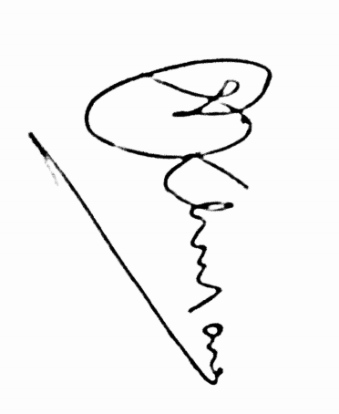

________________ ________________

**Simarpreet Singh Hardik Singh Nain**

**Curator, TEDxChandigarh Bon Nourriture**